**A**

**PROJECT REPORT**

**ON**

**Child Daycare**

**BACHELOR OF COMPUTER APPLICATIONS**

**At**



**SHAH SATNAM JI GIRLS’ COLLEGE, SIRSA**

**(Session: 2024-2025)**

Under the Supervision of: Submitted By:

MS. NISHA LOVELEEN KAUR

Assistant Professor BCA(6th sem)

Computer Science Department 22009115470008

**PREFACE**

In today’s fast-paced world, the role of daycare centers has become increasingly vital in supporting families and fostering early childhood development. This guide aims to explore the significance of quality daycare services, emphasizing their impact on children's social, emotional, and cognitive growth.

Daycare is not merely a place for supervision; it is a nurturing environment where children can explore, learn, and develop foundational skills. As we delve into the various aspects of daycare—from the benefits it offers to best practices for caregivers—we hope to provide valuable insights for parents, educators, and childcare professionals alike.

Through collaboration, innovation, and a commitment to excellence, we can create enriching experiences that lay the groundwork for a bright future for our children. Let us embark on this journey together, recognizing the profound influence that quality daycare can have on the next generation..

**ACKNOWLEDGMENT**

We take this opportunity to express our deepest gratitude to those who have generously helped us in providing the valuable knowledge and it is with real pleasure, that we record our indebtedness to our academic guide, **Teacher Name** Assistant Professor in **College Name** for her counsel and guidance during the preparation of this project and **other College Name**

I would like to take this opportunity to convey my deep sense of gratitude to my External guide **Mr. Ranveer Singh**, for his direction, support and steady motivation. I am extremely obliged to him for his continuous suggestions, help and cooperation, without which it was impossible to achieve the success in the work allocated to me.

At the end I would love to thank all of staff members of Softwizz Technologies Pvt. Ltd. For providing an excellent and healthy environment during work. And finally, we would like to thank each and every person who has contributed in any of the ways in our project.

**Student Name**

**Student Roll No**

**INDEX**

|  |  |  |
| --- | --- | --- |
| **S.No.** | **Title** | **Page No.** |
| 1**.** | Company Profile | 5-6 |
| 2**.** | Introduction of Project | 7-11 |
| 3. | Requirement Analysis  3.1 Introduction  3.2 Problem Analysis | 12-15 |
| 4**.** | Technology Used  4.1 HTML  4.2 CSS  4.3 JS  4.4 Bootstrap  4.5 jQuery  4.6 PHP | 16-32 |
| 5. | Feasibility Study | 33-36 |
| 6. | Software Design | 37-39 |
| 7. | Snapshorts | 40-49 |
| 8. | Testing | 50-55 |
| 9. | Implementation | 56-60 |
| 10. | Conclusion | 61-61 |

**COMPANY PROFILE**

**About Softwizz**

Softwizz is a software development company providing solutions in the field of education, construction, publishing and many more. Our specialists are truly sensitive and responsive to the needs of our clients due to their unwavering dedication and unequalled professionalism, which help our company to deliver wide-ranging and proficient custom web design services.

Softwizz Pvt. Ltd. is leading software development and training group in various domains across the industry like CSE IT, Non IT (ECE, ME, ETC, EEE) and Management based programs. We are in software development industry, corporate training as well as individual training program to meet our market segments.

Softwizz Pvt. Ltd. customized program is to provide the training Software industry with project ready candidates by filling the gap between theoretical knowledge and industry requirement.

**Vision:**

To be the most admired and respected Technology company providing “Best value” software solution and education system.

**Mission:**

To achieve the leadership position in our focus domains and to become a reason for smile for everyone related with the organization in the form of staff, clients and trainees by providing the best services with all the commitment and dedication of our work.

**Core Value:**

Clients first- We exist because of our clients.

Reliability and transparency- committed to be ethical, transparent and reliable in all our operation.

**Services**:

SOFWIZZ offers a wide range of Engineering Projects and Information Technology services. These include:

* Software Development Process
* Software Development Quality
* Software Development Solutions
* Social Media
* E-commerce Solution
* Web Hosting

**Approach**

SOFTWIZZ sees teamwork on every project as the key success ingredient and are responsible for creating this environment. The overall project manager is duty-bound in ensuring effective communication to all stakeholders and at all levels. Teams are built by combining the strengths of the individual members and refining skills to meet and exceed the Client’s expectations. We also believe in a hands-on approach on all our projects. This is why the Director of the firm will always be in control of the key functions on a project. SOFTWIZZ is equipped with the latest technology and has the necessary staff and resources to ensure that best professional service is provided at all

**CHAPTER-1**

**INTRODUCTION TO PROJECT**

**About the project:**

Daycare plays a crucial role in the early development of children, providing a safe and nurturing environment where they can grow, learn, and socialize. In today’s busy world, many families rely on daycare services to support their needs while ensuring their children receive quality care and educational opportunities.

Daycare centers offer a structured setting that promotes not only the well-being of children but also their cognitive and emotional development. Through various activities, children engage in play-based learning, develop essential social skills, and build a foundation for future educational success.

This introduction will explore the different types of daycare, the benefits they provide to families and communities, and the essential qualities that define a high-quality daycare experience. Understanding these aspects is vital for parents and caregivers as they navigate the important decision of choosing the right daycare for their children.

**OBJECTIVES**

1. **Promote Child Development: Foster cognitive, social, emotional, and physical growth through structured activities and play.**
2. **Provide a Safe Environment: Ensure a secure and nurturing setting where children feel protected and cared for.**
3. **Support Socialization: Encourage interaction among peers to develop essential social skills, such as cooperation, sharing, and communication.**
4. **Facilitate Early Learning: Introduce foundational concepts in literacy, numeracy, and critical thinking through engaging and age-appropriate activities.**
5. **Assist Working Families: Offer reliable childcare solutions that enable parents to balance work and family responsibilities effectively.**
6. **Encourage Independence: Help children build confidence and independence by allowing them to explore and make choices in a guided environment.**
7. **Foster Emotional Well-being: Support emotional development by teaching children how to express their feelings and manage conflicts positively.**
8. **Cultivate Relationships: Build strong partnerships between caregivers, parents, and the community to enhance the overall support system for children.**
9. **Promote Inclusivity: Ensure an inclusive environment that respects diversity and meets the needs of all children, regardless of their backgrounds.**
10. **Prepare for School Readiness: Equip children with the skills and readiness needed for a smooth transition into formal education settings.**

**FUNCTIONALITIES**

**Childcare Services: Provide a safe and supervised environment for children during parents' work hours.**

**Educational Activities: Implement age-appropriate learning programs that promote cognitive and social development through play and structured learning.**

**Socialization Opportunities: Facilitate interactions among children to help them develop essential social skills and friendships.**

**Health and Nutrition: Offer nutritious meals and snacks, promoting healthy eating habits and overall well-being.**

**Routine and Structure: Establish daily schedules that provide stability and predictability for children, helping them feel secure.**

**Parental Support: Serve as a resource for parents by providing guidance, education, and regular communication about their child's development.**

**Emotional Support: Foster a nurturing environment that supports children's emotional needs and helps them learn to express their feelings.**

**Inclusivity and Diversity: Create an inclusive environment that respects and celebrates diverse backgrounds and abilities among children.**

**Safety and Security: Maintain high safety standards and protocols to ensure the well-being of all children in care.**

**Skill Development: Promote essential life skills such as problem-solving, teamwork, and self-regulation through various activities and interactions.**

**CHAPTER-2**

**REQUIREMENT ANALYSIS**

This process is also known as feasibility study. In this phase, the team visits the customer and studies their area. They investigate customer needs and their taste. By the end of feasibility study, the team furnishes a document that holds the different specific recommendations for the candidate garden. To understand the nature of the program to be built, the gardener must understand the information given for garden.

Requirement analysis is critical to the success of a program. The requirements should be documented, actionable, measurable, related to the needs.

**Types of Requirements:**

There are some common types of requirements are used as:

**1. User Requirements:**

User requirements, also known as user needs or user expectations, define the needs and expectations of the target users. They outline the specific functionalities and features that users require to meet their goals and perform their tasks effectively. User requirements are crucial in the process as they form the foundation for designing and developing a system that meets user needs.

User requirements can be gathered through various techniques such as interviews, surveys, observations, or workshops with potential users.

**2.** **Architectural Requirements:**

Architectural requirements explain what has to be done by identifying the necessary system architecture of a system.

**3. Structural Requirements:**

Structural requirements explain what has to be done by identifying the necessary structure of a system.

**4. Behavioural Requirements:**

Behavioural requirements explain what has to be done by identifying the necessary behaviour of a system.

**5. Functional Requirements:**

Functional requirements explain what has to be done by identifying the necessary task, action or activity that must be accomplished. Functional requirements analysis will be used as the top-level functions for functional analysis.

**6. Non-functional Requirements:**

Non-functional requirements are requirements that specify criteria that can be used to judge the operation of a system, rather than specific behaviours.

**7. Performance Requirements:**

The extent to which a mission or function must be executed; generally measured in terms of quantity, quality, coverage, timeliness or readiness. During requirements analysis, performance (how well does it have to be done) requirements will be interactively developed across all identified functions based on system life cycle factors; and characterized in terms of the degree of certainty in their estimate, the degree of criticality to system success, and their relationship to other requirements.

**8. Design Requirements:**

The design requirements for a gardening website involve creating a visually appealing and engaging user experience. The website should have a cohesive and consistent design that aligns with the overall brand and theme. This includes selecting an appropriate colour scheme that reflects the natural and vibrant aspects of gardening. Consider using earthy tones, greens, and floral-inspired colours to evoke a sense of nature and tranquillity.

**PROBLEM ANALYSIS**

**Problem Statement**

Users cannot pay online.

Users can’t view online information.

**Proposed System**

Users can give feedback about the site.

Users can access gardening information.

**SPECIFIC REQUIREMENTS**

**1. Processing Requirements**

In this step we analyzed the processing capabilities of the system on which the proposed system would be developed and the specification is divided into two categories namely:

* Minimum Hardware Requirements

|  |  |  |
| --- | --- | --- |
| 1 | System Type | 32- bit or 64-bit operating System |
| 2 | RAM | 4 GB |
| 3 | Hard Disk | 1 TB of free HDD space for Internet Cache. |
| 4 | Internet Connection | 512Kbps |
| 5 | Processor Speed | 5.2 GHz |

|  |  |  |
| --- | --- | --- |
| I. | Operating System | Windows 8, 10 or 11 |
| II. | Front End | HTML5 and CSS3,Bootstrap |
| III. | Back End | MYSQL 5.2.x |
| IV. | Web Server | APACHE |
| V. | Designing Software | VS Code or Notepad++ |

* Minimum Software Requirements

**CHAPTER-3**

**TECHNOLOGY USED**

**1.HTML:**

HTML stands for HyperText Markup Language. It is the standard markup language used for creating web pages and applications. HTML uses a set of tags and attributes to structure the content and define the layout of a web page. These tags are enclosed in angle brackets and are used to mark up elements such as headings, paragraphs, images, links, tables, and more.

Some additional concepts and features in HTML are:

**1. Elements and Tags:**

HTML documents are composed of elements, which are defined by tags. Tags are used to enclose content and provide structure to the document. For example, ‘<p>’ tags define paragraphs, ‘<h1>’ to ‘<h6>’ tags define headings of different levels, ‘<ul>’ and ‘<li>’ tags create unordered lists, and so on.

**2. Attributes:**

HTML tags can have attributes that provide additional information or modify the behaviour of the element. Attributes are specified within the opening tag of an element. For example, the ‘<img>’ tag has the ‘src’ attribute to specify the image source, and the ‘<a>’ tag has the ‘href’ attribute to define the URL of the link.

**3. Semantic Elements:**

HTML5 introduced a set of semantic elements that give meaning and structure to the content. These elements convey the purpose or role of the content, making it more accessible and providing better search engine optimization. Some semantic elements include ‘<header>’,’ <nav>’, ‘<main>’, ‘<section>’, ‘<article>’, ‘<footer>’, and ‘<aside>’.

**4. Forms:**

HTML provides form elements to collect user input, such as text fields, checkboxes, radio buttons, dropdown lists, and more. The ‘<form>’ tag defines a form, and the form elements are enclosed within it. User input can be processed using server-side programming languages like PHP or client-side scripting with JavaScript.

**5. Tables:**

HTML allows you to create tables using the <table>, <tr> (table row), <th> (table header), and <td> (table data) tags. Tables are useful for displaying structured data, and you can apply CSS styles to enhance their appearance.

These are just a few key concepts in HTML. HTML is a versatile language with a wide range of features and capabilities for creating interactive and visually appealing web pages. By combining HTML with CSS and JavaScript, you can create rich and dynamic web experiences.

**Advantages:**

Advantages of HTML are:

1. HTML is a universal language used for creating web pages, ensuring compatibility across all web browsers and platforms.
2. Its simple syntax makes it easy to learn and start building web pages quickly, even for beginners.
3. HTML files are lightweight and text-based, making them easy to edit with any plain text editor.
4. It allows for a flexible structure, organizing content into headings, paragraphs, lists, tables, and more.
5. Hyperlinking capability enables interconnected web pages, facilitating smooth navigation between different resources.
6. HTML works seamlessly with CSS and JavaScript, enabling stylish designs and interactive functionalities.
7. Properly structured HTML can improve search engine visibility and ranking, benefiting search engine optimization (SEO).
8. Semantic tags enhance content meaning and accessibility, benefiting both users and search engines.
9. It adheres to web standards set by W3C, ensuring consistency and interoperability across the web.
10. HTML facilitates rapid prototyping and efficient development of web pages, allowing designers to test ideas quickly.
11. With HTML5, responsive design features enable websites to adapt to different screen sizes and devices.
12. It supports multimedia elements like images, audio, video, and interactive forms, enhancing user experience.
13. HTML allows developers to create accessible websites usable by people with disabilities.
14. Being open-source and free, anyone can use HTML without licensing restrictions.
15. HTML's ongoing development and community support ensure its relevance and longevity as a fundamental web technology.

**2. CSS:**

CSS (Cascading Style Sheets) is a stylesheet language used to describe the visual presentation of an HTML document. It allows you to control the appearance and layout of HTML elements on a web page. CSS works by targeting HTML elements and applying styles to them using selectors and property-value pairs.

There are three main types of CSS that are commonly used:

**1. Inline CSS:**

Inline CSS involves applying styles directly to individual HTML elements using the style attribute. Inline styles have the highest specificity and will override styles applied through other methods.

Inline CSS is typically used for small, one-off style modifications or when a specific style needs to be applied to a single element.

**2. Internal CSS:**

Internal CSS is defined within the <style> tags in the <head> section of an HTML document. The CSS rules defined inside these tags apply to the entire document or a specific section.

Internal CSS allows you to define styles for multiple elements within a single HTML document. However, it can become less manageable as the document grows larger.

**3. External CSS:**

External CSS involves creating a separate CSS file with a .css extension and linking it to the HTML document using the <link> tag. The CSS file contains all the style definitions, which can be reused across multiple HTML documents.

Overall, the choice of CSS type depends on the specific requirements, the scale of your styles, and the level of reusability needed. External CSS files are the most commonly used and recommended approach for larger s, while inline and internal CSS are more suitable for smaller modifications or specific cases.

**Features**:

Features of CSS are:

1. **Selectors**:

CSS allows you to select HTML elements based on their tag names, classes, IDs, attributes, or relationship with other elements. Selectors help specify which elements should be styled or affected by CSS rules.

1. **Style Declarations**:

CSS uses style declarations to define the visual properties of selected elements. Style declarations consist of a property and its corresponding value, such as color: blue; to set the text color to blue.

1. **Box Model**:

CSS includes a box model that defines how elements are displayed and how their dimensions are calculated. The box model consists of properties like width, height, padding, border, and margin, allowing precise control over the positioning and spacing of elements.

1. **Layout and Positioning**:

CSS provides various techniques for controlling the layout and positioning of elements on a web page. This includes properties like display, float, position, and flexbox or grid layouts, allowing developers to create complex and responsive page layouts.

1. **Typography**:

CSS enables the customization of typography, including font family, font size, font weight, line height, and text alignment. It allows for consistent and visually appealing typography across a website.

1. **Colors and Backgrounds**:

CSS provides a wide range of options for defining colors and backgrounds. It supports color names, hexadecimal color codes, RGB values, gradients, and transparency settings. Background images and patterns can also be applied to elements.

1. **Transitions and Animations**:

CSS allows the creation of smooth transitions and animations. Properties like transition and animation can be used to specify the timing, duration, and easing of transitions between different styles or to create complex animations.

1. **Media Queries**:

CSS includes media queries that enable responsive web design. By specifying different CSS rules based on the characteristics of the device or viewport size, developers can create layouts that adapt and adjust to different screen sizes and devices.

1. **Selectors and Pseudo-classes**:

CSS offers a wide range of selectors and pseudo-classes to target specific elements or states. Pseudo-classes like: hover, :focus, and :active allow the styling of elements based on user interactions or states.

1. **Modularity and Reusability**:

CSS promotes modularity and reusability by allowing the definition of styles in separate style sheets and linking them to multiple HTML documents. This facilitates consistent styling across multiple pages and simplifies maintanence.

**Advantages**:

1. **Separation of Concerns:**

CSS allows for the separation of style and presentation from the structure and content of a web page. This separation makes it easier to maintain and update the design and layout of a website without affecting the underlying HTML structure. It enhances code reusability and promotes a more modular and organized development approach.

1. **Consistent Styling:**

CSS enables consistent styling across a website by defining styles in a central location and applying them to multiple web pages. This ensures that all pages have a cohesive look and feel, enhancing the user experience and reinforcing the brand identity.

1. **Flexible Layouts:**

CSS provides flexible layout options, allowing developers to create responsive and adaptive designs that adapt to different screen sizes and devices. CSS features like media queries, flexbox, and grid layouts enable the creation of fluid and dynamic layouts that automatically adjust based on the user's viewport.

1. **Efficient Styling:**

CSS promotes efficient styling by allowing the use of classes and IDs to target specific elements or groups of elements. This eliminates the need to repeat styling instructions for each occurrence of an element, reducing code redundancy and file size. CSS also offers inheritance, enabling styles to cascade from parent elements to their children, further reducing the amount of code required.

1. **Improved Page Loading Speed:**

By separating the styles from the HTML structure, CSS allows for the creation of lightweight and optimized web pages. This leads to faster page loading times, enhancing the overall user experience and reducing bounce rates.

1. **Easy Maintenance and Updates:**

With CSS, making changes to the design or layout of a website is straightforward. Modifying a style in a CSS file automatically applies the changes to all elements using that style, eliminating the need to update each individual page. This simplifies maintenance and saves time and effort in managing the website.

1. **Browser Compatibility:**

CSS is supported by all modern web browsers, ensuring cross-browser compatibility. Developers can write CSS rules once and expect them to be rendered consistently across different browsers and platforms. CSS also provides fallback options to handle scenarios where certain CSS features may not be supported in older browsers.

1. **Extensibility and Customizability:**

CSS supports the use of CSS frameworks, pre-processors, and libraries, allowing developers to extend its capabilities and streamline their workflow. Additionally, CSS can be easily customized and tailored to meet specific design requirements and preferences.

1. **Accessibility:**

CSS facilitates the creation of accessible websites by providing semantic and structural markup options. CSS allows for the separation of content and presentation, making it easier to implement accessibility best practices, such as providing alternative text for images or defining appropriate heading structures.

**Future Compatibility:**CSS is continually evolving, with new features and modules being added to the language. It ensures that websites built with CSS can adapt to future design trends and take advantage of emerging techniques.

**3.JQuery:**

jQuery is a popular JavaScript library that simplifies HTML document traversal, event handling, and animation. It provides a concise and easy-to-use syntax for interacting with HTML elements, manipulating the DOM (Document Object Model), making AJAX requests, and handling events.

Some key features and capabilities of jQuery include:

**1. DOM Manipulation:**

jQuery allows you to select and manipulate HTML elements using CSS-style selectors. You can modify their attributes, content, styles, and position within the DOM.

**2. Event Handling:**

jQuery provides methods to attach event handlers to HTML elements. You can respond to user interactions such as clicks, mouse movements, form submissions, and more.

**3. AJAX:**

jQuery simplifies making asynchronous HTTP requests using the AJAX (Asynchronous JavaScript and XML) technique. You can retrieve data from a server without reloading the entire page and update parts of the page dynamically.

**4. Animations:**

jQuery offers a set of animation methods to create smooth transitions and effects. You can animate HTML elements by changing their properties, such as opacity, position, width, or height.

**5. Utilities:**

jQuery includes a range of utility functions for tasks like iterating over arrays or objects, working with JSON data, manipulating strings, handling browser detection, and managing the execution of functions.

jQuery simplifies many common JavaScript tasks, providing a concise and efficient way to work with HTML, CSS, and JavaScript in a cross-browser manner. However, note that with modern JavaScript capabilities and browser APIs, many tasks that were traditionally handled by jQuery can now be accomplished directly using JavaScript.

**Advantages:**

Advantages of jQuery are:

1. **Simplified DOM Manipulation:**

jQuery provides a simple and concise syntax to manipulate the Document Object Model (DOM). It allows developers to easily select and modify elements on a web page, making it quicker and more efficient compared to traditional JavaScript.

1. **Cross-Browser Compatibility:**

jQuery abstracts browser-specific differences, ensuring consistent behavior across various browsers. Developers can write code that works reliably on different browsers without worrying about browser inconsistencies.

1. **Event Handling:**

jQuery simplifies event handling by providing easy-to-use methods to attach event listeners to elements. It allows for convenient management of user interactions, such as clicks, keypresses, or form submissions.

1. **AJAX Support:**

jQuery streamlines AJAX (Asynchronous JavaScript and XML) calls, making it easier to fetch and update data from the server without requiring a full page refresh. This enhances the user experience by providing seamless and interactive content updates.

1. **Animation and Effects:**

jQuery offers built-in animation and effects functions, enabling smooth animations and transitions. Developers can create visually appealing effects, such as fading, sliding, or toggling elements, with minimal effort.

1. **Extensive Plugin Ecosystem:**

jQuery has a vast ecosystem of plugins and extensions that provide additional functionality. These plugins allow developers to integrate various features, such as image sliders, form validation, and date pickers, into their projects easily.

1. **DOM Traversal:**

jQuery simplifies traversing and manipulating the DOM tree. Developers can easily find and work with parent, child, or sibling elements, simplifying complex DOM manipulations.

1. **Chaining:**

jQuery supports method chaining, allowing developers to perform multiple operations on the same set of elements in a single line of code. This results in more concise and readable code.

1. **Community and Documentation:**

jQuery has a large and active community, which means abundant resources, tutorials, and support are available. The extensive documentation and examples make it easier for developers to get started and find solutions to their queries.

1. **Performance Optimization:**

jQuery is designed to be efficient and lightweight. It helps optimize web page loading times and performance by minimizing code and enhancing script execution speed.

By leveraging these advantages, jQuery allows developers to create powerful and interactive web applications with less code, faster development time, and improved cross-browser compatibility.

1. **Bootstrap:**

Bootstrap is a popular front-end framework that provides a collection of pre-built HTML, CSS, and JavaScript components for creating responsive and mobile-first web pages and applications. It simplifies the process of designing and styling websites by offering a wide range of ready-to-use components, layout options, and utility classes.

Key features and benefits of Bootstrap include:

1. **Responsive Design:**

Bootstrap is built with a mobile-first approach, ensuring that websites and applications look and function well on various devices and screen sizes. It provides a responsive grid system that allows you to create fluid layouts and adapt the design to different viewport sizes.

1. **CSS Components:**

Bootstrap includes a vast library of reusable CSS components, such as navigation bars, buttons, forms, tables, cards, modals, carousels, and more. These components are styled and designed to provide a consistent and visually appealing user interface.

1. **Layout Options:**

Bootstrap offers a flexible grid system that enables you to create responsive layouts with ease. The grid system is based on a 12-column layout, and you can customize the number of columns per row, column widths, and offsets to achieve the desired layout structure.

1. **CSS Customization:**

Bootstrap provides extensive CSS classes and utility styles that allow you to modify the appearance and behavior of components. You can easily customize colors, typography, spacing, and other visual aspects by overriding the default styles or using predefined utility classes.

1. **JavaScript Plugins:**

Bootstrap includes a set of JavaScript plugins that enhance the functionality of components. These plugins provide interactive features like dropdown menus, modals, tooltips, carousels, form validation, and more. They are implemented using jQuery, but Bootstrap also provides a version called "Bootstrap Native" that uses vanilla JavaScript without relying on jQuery.

1. **Community and Documentation:**

Bootstrap has a large and active community of developers, which means you can find a wealth of resources, tutorials, themes, and extensions created by the community. Bootstrap also has comprehensive documentation that guides you through the framework's features and usage.

To get started with Bootstrap, you can include the Bootstrap CSS and JavaScript files in your HTML document, either by downloading them and hosting them locally or by using the Bootstrap CDN (Content Delivery Network). Then, you can utilize the available classes, components, and grid system to structure and style your web pages.

**Advantages:**

Advantages of bootstrap are:

1. **Responsive Design:**

Bootstrap provides a responsive grid system and pre-designed components that automatically adjust to different screen sizes and devices. This ensures that websites built with Bootstrap are mobile-friendly and adapt well to various devices, including smartphones, tablets, and desktops.

1. **Time-Saving:**

Bootstrap offers a collection of ready-to-use components and styles, allowing developers to build websites quickly and efficiently. By using Bootstrap's pre-built templates, UI elements, and styling, developers can save time and focus on customizing and fine-tuning specific aspects of the design.

1. **Consistency and Uniformity:**

Bootstrap enforces a consistent and uniform design language across web pages. This consistency improves the user experience by providing a familiar and cohesive interface throughout the website.

1. **Cross-Browser Compatibility:**

Bootstrap is designed to be compatible with all modern web browsers. By using Bootstrap, developers can ensure that their websites look and function consistently across different browsers and platforms.

1. **Customizability:**

While Bootstrap provides a set of default styles and components, it is highly customizable. Developers can easily modify the framework's variables and components to match the specific design requirements of their projects.

1. **Documentation and Community:**

Bootstrap has extensive documentation, making it easy for developers to understand and use the framework effectively. Additionally, the Bootstrap community is active and supportive, providing tutorials, examples, and help for fellow developers.

1. **Flexibility**:

Bootstrap can be used as a whole or selectively for specific components. Developers can choose to include only the necessary parts of Bootstrap, reducing the overall file size and optimizing website performance.

1. **Accessibility:**

Bootstrap follows accessibility best practices, making it easier to create websites that are usable and accessible to people with disabilities.

1. **Support for Modern Features:**

Bootstrap is regularly updated to support modern web design trends and features. It ensures that websites built with Bootstrap remain up-to-date and relevant.

1. **Integration with JavaScript Libraries:**

Bootstrap integrates well with popular JavaScript libraries and plugins, enabling developers to enhance the website's functionality with additional interactive features easily.

1. **Community-Driven Development:**

Being open-source, Bootstrap benefits from contributions and feedback from a large community of developers. This result in continuous improvements, bug fixes, and feature enhancements.

1. **Grid System:**

Bootstrap's grid system allows developers to create responsive layouts with columns and rows. This makes it easier to design complex page structures and maintain a consistent grid alignment.

By leveraging these advantages, Bootstrap empowers developers to create visually appealing, responsive and feature-rich websites efficiently , making it one of the most widely used front-end frameworks in the web development community.

**5. PHP**

PHP is a popular server-side scripting language used for web development. It is especially well-suited for creating dynamic and interactive web applications.

Features of PHP:

**1. Server-Side Scripting:**

PHP is primarily used on the server side of web development. It runs on the web server and generates dynamic content to be sent to the client's web browser.

**2. Open Source:**

PHP is an open-source language, which means it is freely available for use, distribution, and modification. It has a large and active community of developers contributing to its growth.

**3. Embedded in HTML:** PHP code can be embedded directly into HTML, allowing developers to mix PHP with HTML for creating dynamic web pages.

**4. Cross-Platform Compatibility:** PHP is compatible with various operating systems, including Windows, macOS, Linux and Unix, making it a versatile choice for web development.

1. **Wide Adoption:** PHP is widely used and has been the backbone of popular Content Management Systems (CMS) like WordPress, Joomla, and Drupal, which power a significant portion of websites on the internet.
2. **Support for Databases:** PHP has robust support for connecting to various databases, enabling seamless integration with database systems like MySQL, PostgreSQL, and more.
3. **Scalability:** PHP is highly scalable and suitable for developing small websites as well as large-scale web applications.
4. **Security Considerations:** Like any web development language, PHP requires careful consideration of security best practices to prevent vulnerabilities and protect against potential attack.
5. **Rich Library Support:** PHP has a vast library of functions and extensions that simplify complex tasks, making development faster and more efficient.
6. **Frameworks and Tools:** There are numerous PHP frameworks, such as Laravel, Symfony and CodeIgniter, that provid e structured development approaches and built-in features to streamline the development process.

**Advantages:**

Advantages of PHP are:

PHP (Hypertext Preprocessor) is a popular server-side scripting language with several advantages that make it a preferred choice for web development:

**1. Open Source:** Being open-source, PHP is freely available, and developers can use, modify, and distribute it without any cost.

**2. Easy to Learn and Use:** PHP has a simple and intuitive syntax, making it easy for beginners to learn and start developing web applications quickly.

**. Wide Compatibility:** PHP is compatible with various operating systems (Windows, macOS, Linux, Unix ) and supports numerous web servers (Apache, Nginx) and databases (MySQL, PostgreSQL).

**4. Speed and Performance:** PHP is designed to execute quickly, resulting in faster load times for web pages and efficient handling of server-side processes.

**5. Integration Capabilities:** PHP can seamlessly integrate with different databases, web services, and APIs, making it versatile for creating dynamic and interactive web applications.

**Large Community and Support:** PHP has a massive and active community of developers, providing extensive documentation, tutorials, and support for troubleshooting issues.

**7. Scalability:** PHP applications can be easily scaled to accommodate increasing user demands and website traffic.

**8. Framework Support:** PHP has robust frameworks like Laravel, Symfony, and CodeIgniter, which offer pre-built modules, templates, and tools to expedite development and maintain code consistency.

**9. Security Features:** PHP has evolved over the years to include various security features and functions, making it safer against common web application vulnerabilities when properly implemented.

**10. Continuous Development and Updates:** PHP is continually updated and improved, with each version bringing new features, enhancements, and better performance.

**11. Interoperability:** PHP supports interoperability with other languages, allowing developers to use it in conjunction with other tools and technologies.

**12. Cost-Effective Solutions:** As an open-source technology, PHP reduces development costs, making it an attractive option for businesses and developers.

Due to these advantages, PHP remains a popular choice for web development, especially for dynamic and data-driven web application

**CHAPTER-4**

**FEASIBILITY STUDY**

A feasibility study evaluates the practicality and viability of the venture. It examines various aspects to determine whether it is feasible and economically viable.

1. **Market Analysis:**

Assess the demand and potential market for services or products. Identify the target market segment, their preferences, and needs. Analyze the competition, market trends, and potential growth opportunities. Consider factors such as the size of the target market, customer demographics, and purchasing behavior.

1. **Technical Analysis:**

Evaluate the technical requirements. Determine the necessary resources, equipment, and infrastructure needed to support the operations. Assess factors like the availability of suitable land or space for gardening activities, access to water supply, and required tools or machinery. Consider the technical skills and expertise required for efficient gardening operations.

1. **Financial Analysis:**

Conduct a thorough financial analysis. Estimate the initial investment required for land, infrastructure, equipment, and marketing. The operational costs, including labor, materials, utilities, and maintenance. Assess the potential revenue streams and pricing strategies. Calculate the expected return on investment (ROI) and determine the profitability.

1. **Operational Analysis:**

Evaluate the operational aspects. Consider the day-to-day activities involved, such as plant cultivation, landscaping, maintenance, or product sourcing. Assess the availability of skilled labor or expertise required for different operations. Identify any challenges or risks associated with operational efficiency and develop strategies to mitigate them.

1. **Legal and Regulatory Analysis:**

Understand the legal and regulatory requirements for operating a gardening business. Identify the permits, licenses, or certifications needed to comply with local regulations. Consider environmental regulations, zoning laws, health and safety standards, and any other relevant legal obligations. Assess the potential impact of these regulations on the feasibility and develop a plan for compliance.

1. **Marketing and Sales Analysis:**

Develop a marketing and sales strategy. Identify the target customer segments and determine the most effective channels to reach them. Define the unique selling propositions (USPs) of the gardening business and develop a brand identity. Analyze pricing strategies, promotional activities, and distribution channels to maximize market penetration and customer acquisition.

1. **Risk Analysis:**

Identify and assess potential risks and challenges associated. Consider factors such as changing market conditions, weather-related risks, pest infestations, supply chain disruptions, or fluctuations in the cost of materials. Develop risk mitigation strategies and contingency plans to address these potential challenges.

1. **Environmental and Social Feasibility**:

Consider the environmental impact and sustainability of the gardening project. Assess if the project aligns with environmentally friendly practices, such as organic gardening or water conservation. Evaluate the social impact of the project, including any community benefits, educational opportunities, or partnerships with local organizations.

1. **Legal and Regulatory Compliance:**

Assess the legal and regulatory requirements associated with gardening activities. Determine if there are any permits, licenses, or certifications needed to operate the project. Ensure compliance with local, regional, and national regulations regarding plant sales, environmental practices, or pesticide usage.

1. **Supply Chain and Sourcing:**

Evaluate the availability and reliability of the supply chain for gardening products, tools, seeds, or plants. Consider the sourcing options, including local suppliers, wholesale distributors, or direct imports. Assess the potential risks or challenges related to supply chain management, such as seasonal availability or price fluctuations.

1. **Marketing and Promotion:**

Analyze the marketing strategies and promotional activities required to attract customers and generate demand for the gardening project. Identify target marketing channels, such as online platforms, social media, local events, or collaborations with community organizations. Assess the effectiveness and costs associated with marketing campaigns.

1. **Seasonality and Demand Fluctuations:**

Consider the seasonal nature of gardening activities and assess the impact of demand fluctuations throughout the year. Evaluate strategies to manage the off-season periods, such as diversification of products or services, or offering gardening-related education or workshops.

1. **Operational Considerations:**

Evaluate the operational requirements and resources needed for the gardening project. This includes staffing needs, skills required, training programs, and maintenance of equipment and facilities. Assess the scalability of operations to accommodate potential growth or expansion in the future.

1. **Social and Cultural Acceptance:**

Evaluate the social and cultural acceptance of the gardening project within the target market. Consider local preferences, gardening traditions, or cultural factors that may influence customer behavior or receptiveness to the project.

1. **Sustainability and Resource Management:**

Assess the sustainability practices and resource management strategies for the gardening project. Consider methods for water conservation, waste management, use of organic or sustainable gardening techniques, and energy-efficient practices.

1. **Partnerships and Collaborations:**

Explore potential partnerships or collaborations with local organizations, educational institutions, or gardening communities. This can enhance the project's visibility, support knowledge sharing, and provide opportunities for networking and cross-promotion.

By conducting a comprehensive feasibility study, you can evaluate the viability and potential success of a gardening business. It helps to identify potential opportunities, risks, and areas for improvement, allowing you to make informed decisions and develop a solid business plan

**CHAPTER-5**

**SOFTWARE DESIGN**

System analysis involves studying the existing processes, identifying areas for improvement, and designing an effective and efficient system to meet the project's objectives. Here are the key components of system analysis:

1. **Understanding Current Processes**:

Start by thoroughly understanding the processes, including tasks, workflows, and interactions among stakeholders. Identify pain points, bottlenecks, and inefficiencies in the existing system.

1. **Defining Project Objectives:**

Clearly define the objectives of the project. Determine the specific goals, requirements, and expected outcomes. This could include improving productivity, streamlining operations, enhancing customer experience, or introducing new services or products.

1. **Requirements Gathering:**

Engage with stakeholders, end-users, and domain experts to gather requirements for the new system. Identify their needs, preferences, and challenges. Document functional and non-functional requirements, including features, functionalities, user interfaces, data management, and integration requirements.

1. **Data Analysis:**

Analyze the data requirements for the project. Identify the types of data that need to be collected, stored, and analyzed, such as plant information, customer data, inventory records, or sales data. Determine data sources, data formats, and data management processes.

1. **System Design:**

Based on the gathered requirements, design the system architecture and determine the appropriate technologies, tools, and platforms to be used. Create system models, diagrams, and prototypes to visualize the proposed system and obtain feedback from stakeholders.

1. **Process Redesign:**

Identify opportunities for process improvement and redesign. Streamline workflows, eliminate redundant tasks, and automate manual processes wherever possible. Consider integrating technology solutions, such as inventory management systems, e-commerce platforms, or customer relationship management (CRM) tools, to enhance efficiency.

1. **User Experience Design:**

Focus on designing a user-friendly and intuitive interface for the system. Consider user feedback, usability testing, and best practices in user experience (UX) design. Ensure that the system is accessible, responsive, and meets the needs of different user roles and personas.

1. **System Testing:**

Conduct comprehensive testing to ensure the functionality, performance, and reliability of the system. Test individual components, integration points, and end-to-end processes. Perform user acceptance testing (UAT) to validate that the system meets the specified requirements and satisfies user expectations.

1. **Training and Documentation:**

Develop training materials and conduct training sessions to familiarize stakeholders and end-users with the new system. Provide comprehensive documentation, including user guides, system manuals, and troubleshooting guides, to support system understanding and usage.

1. **Implementation and Deployment:**

Plan the implementation and deployment of the new system. Consider factors such as data migration, system configuration, infrastructure setup, and user onboarding. Ensure

smooth transition from the old system to the new one, minimizing disruption and downtime.

System analysis ensures a comprehensive understanding of the requirements, processes, and interactions within the system. It forms the basis for designing, developing, and implementing an effective system that meets the needs of stakeholders and enhances the experience.

**Snapshorts**

**HOME**

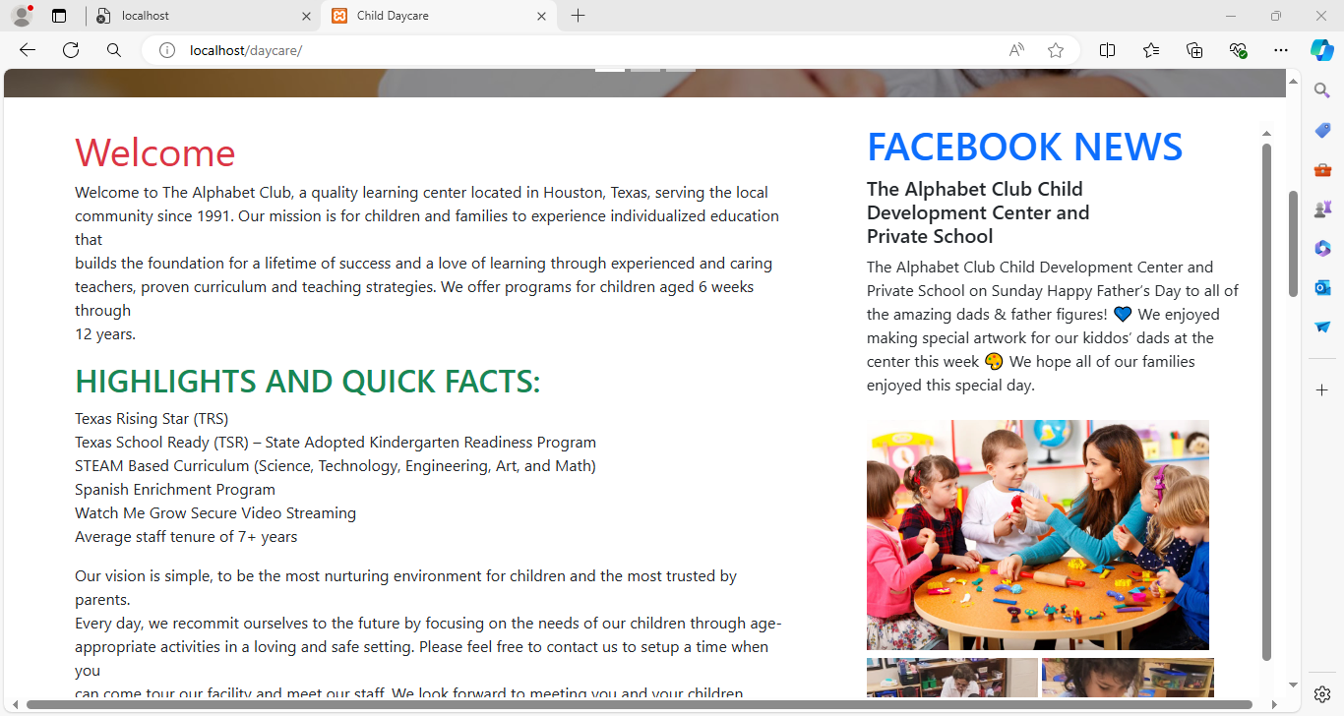

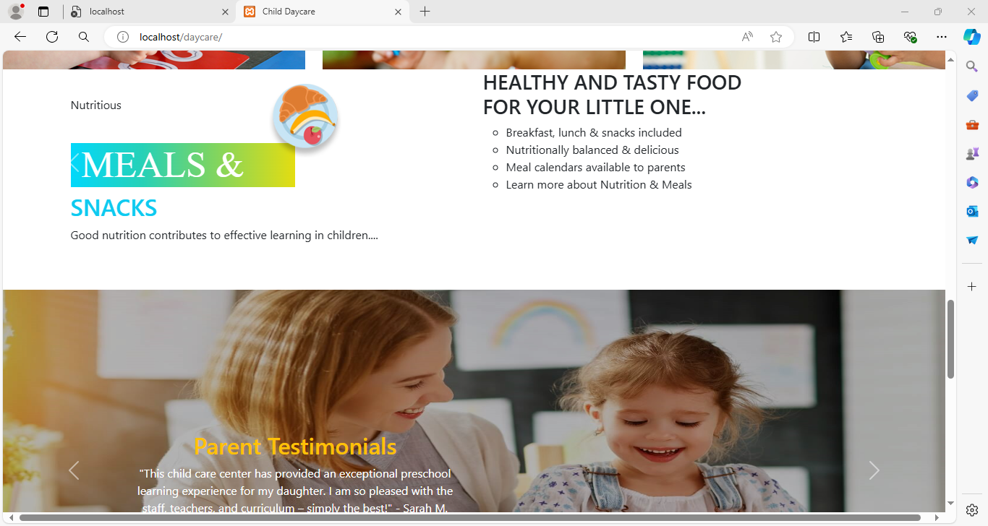

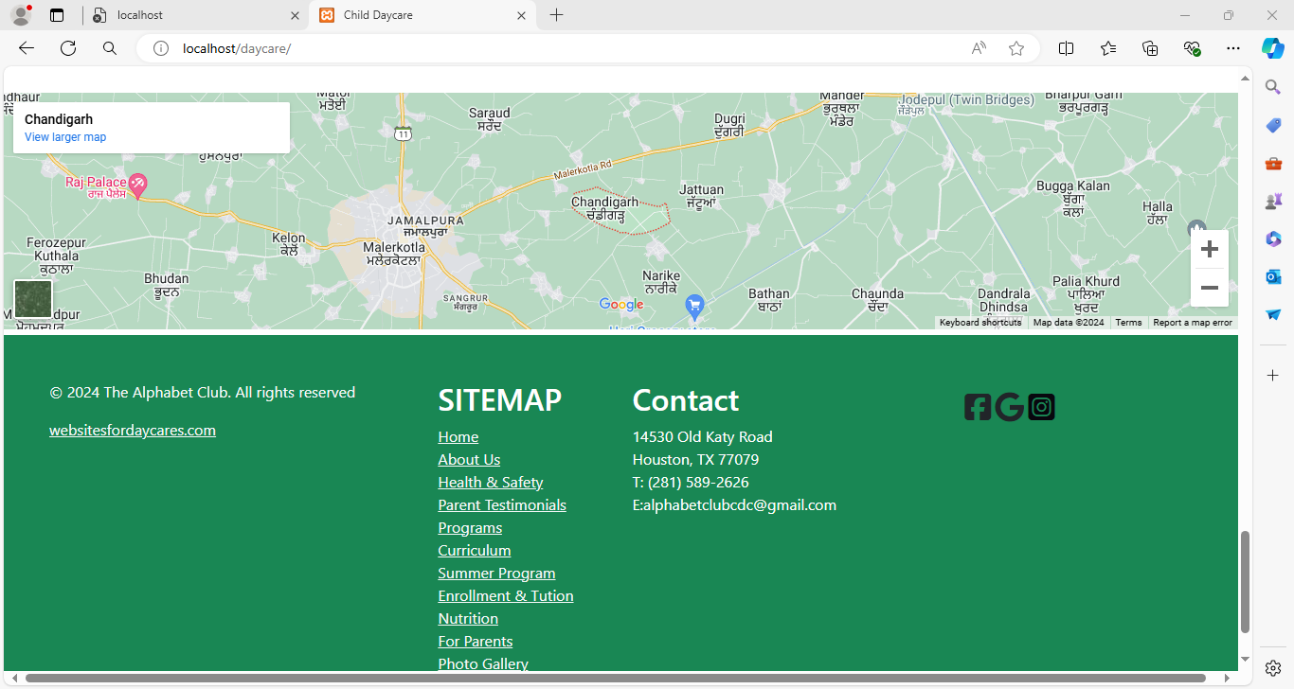

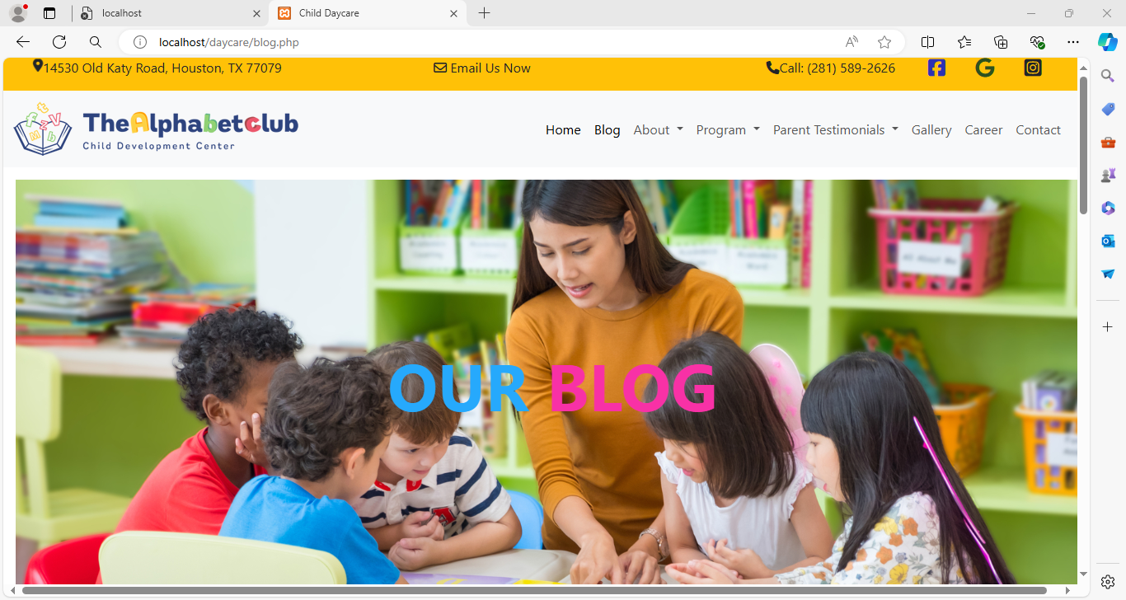**BLOG**

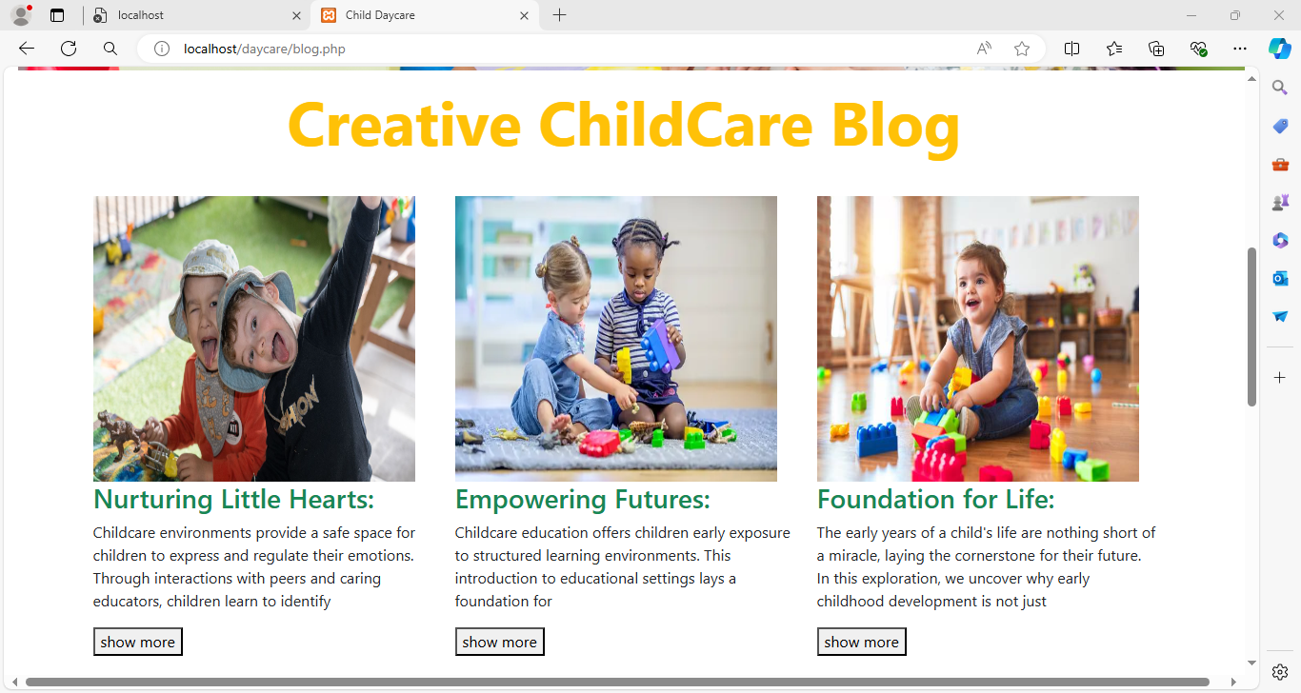

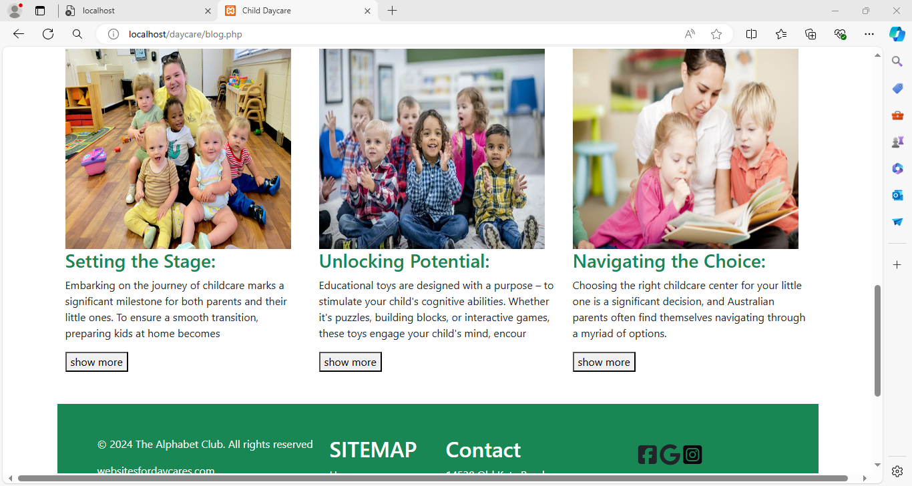

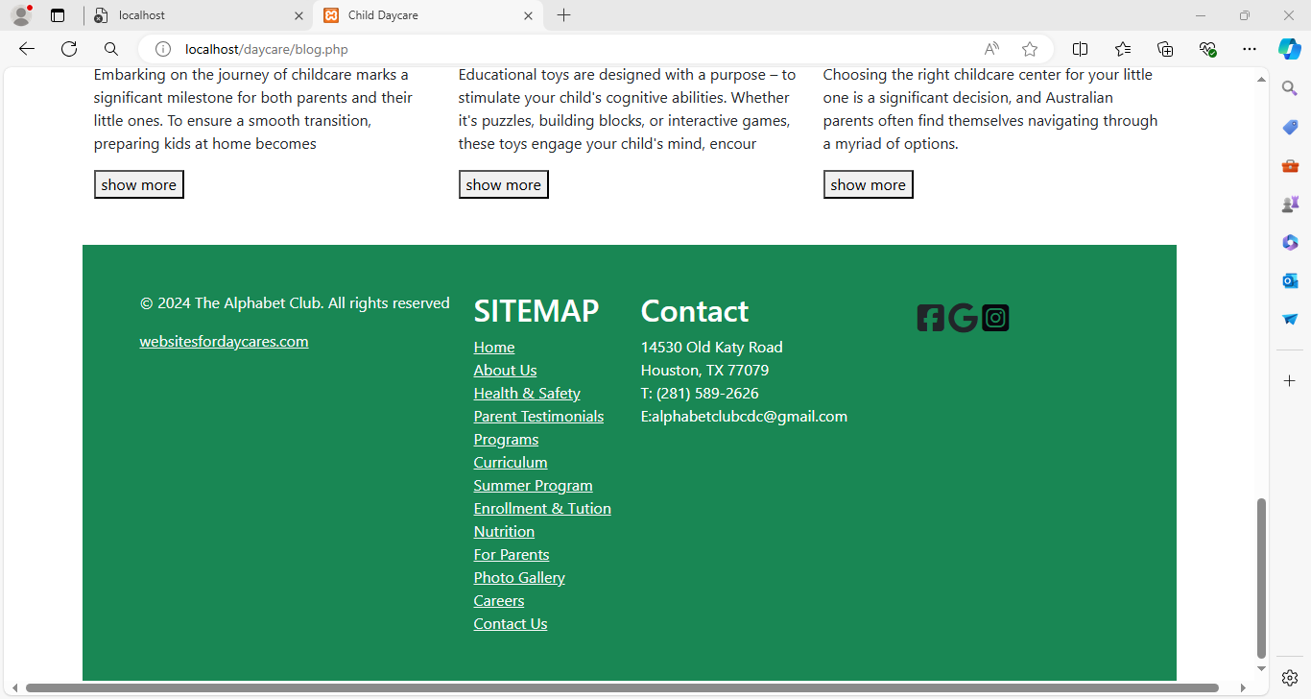

**ABOUT**

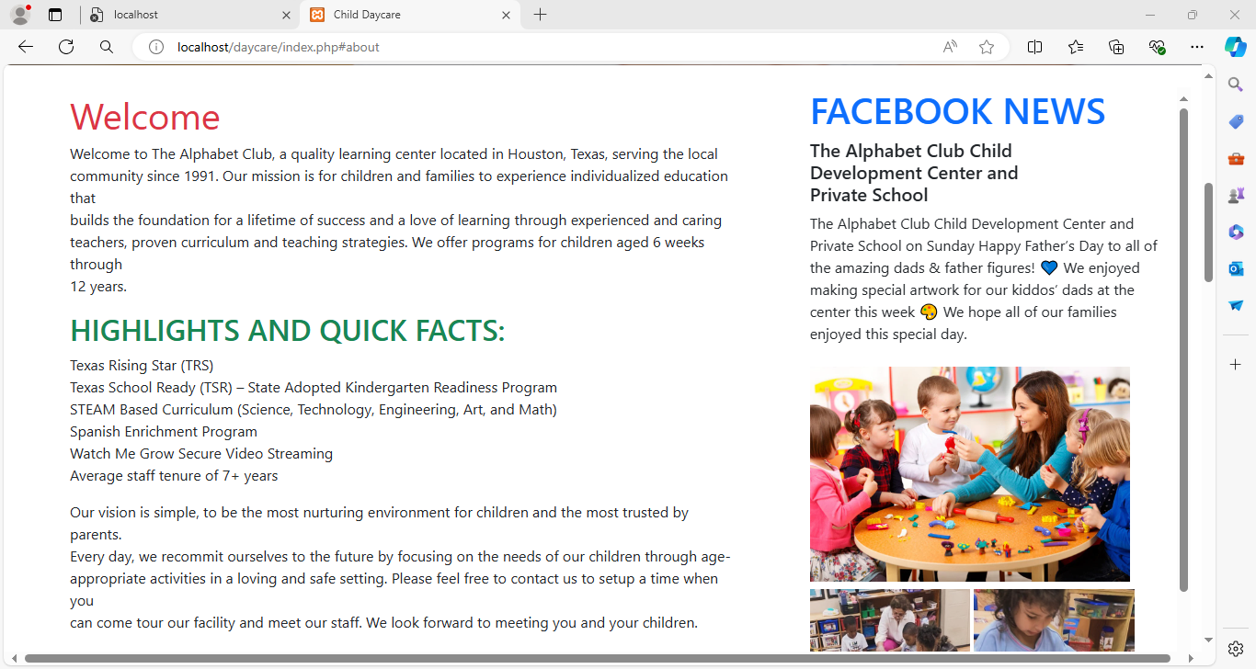

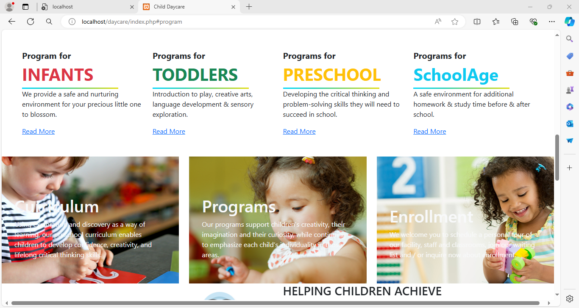**PROGRMAS**

**GALLERY**

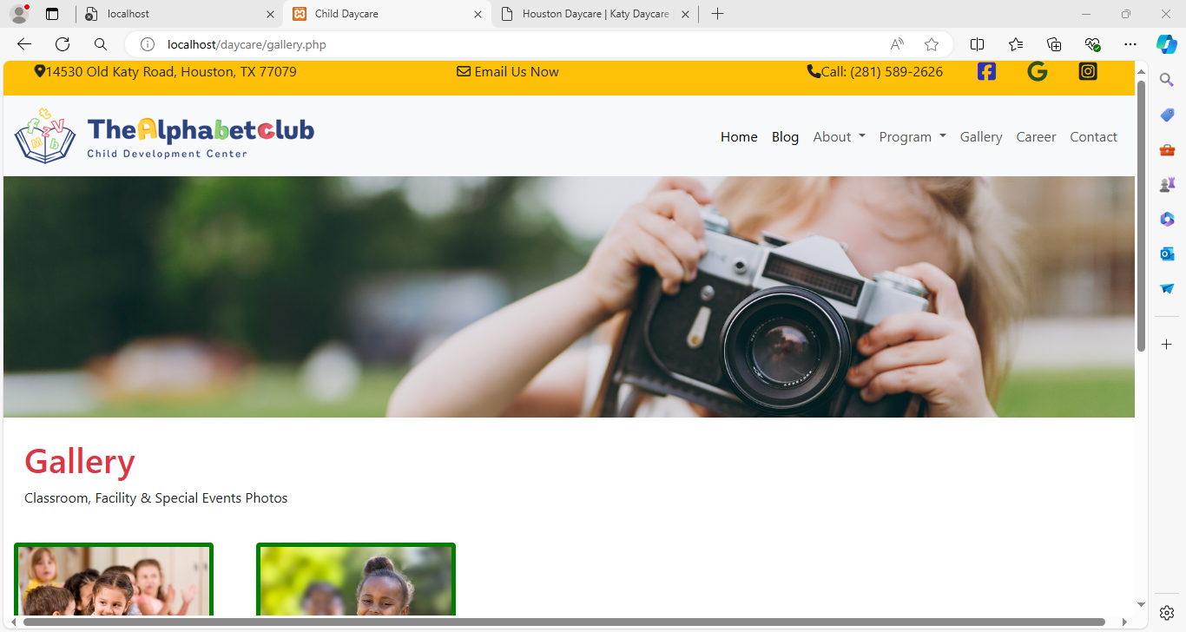

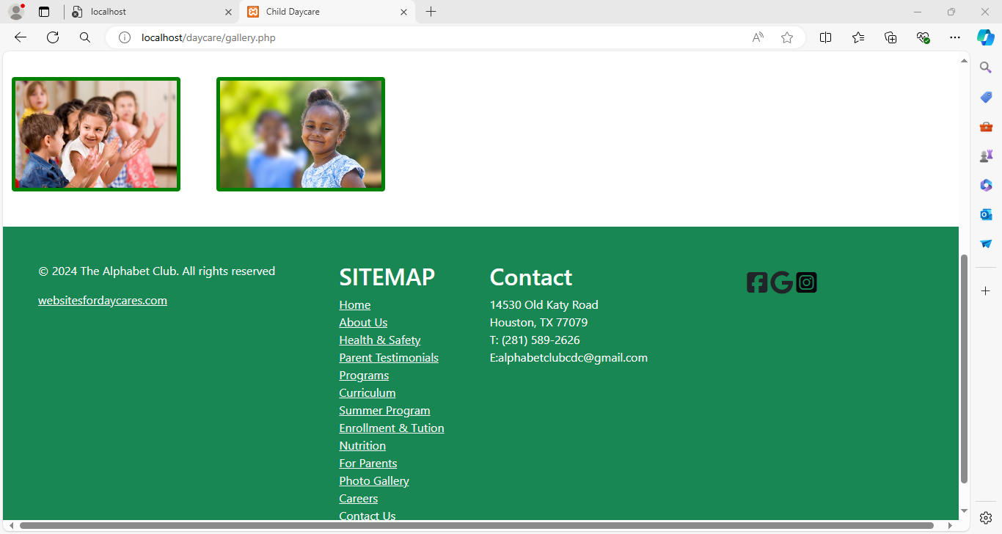

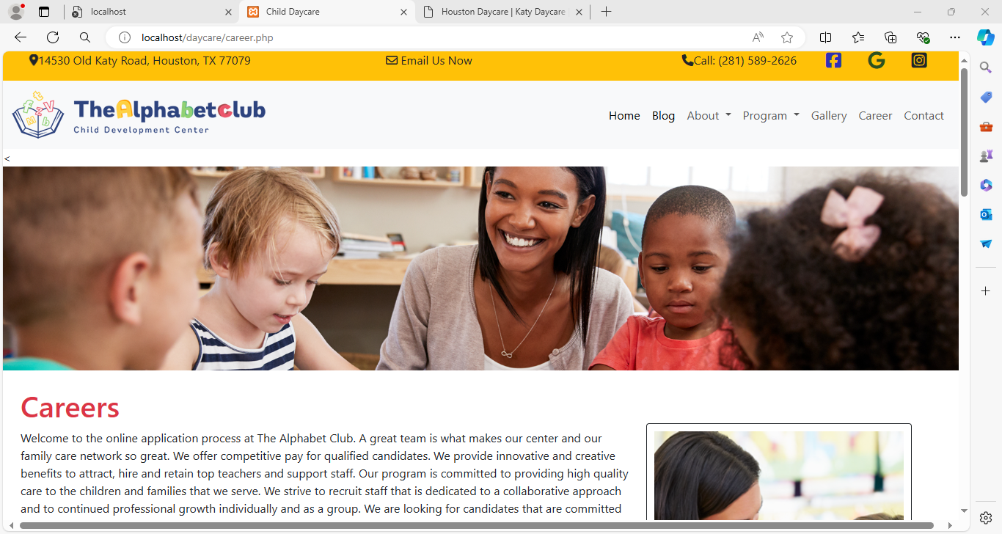**CAREER**

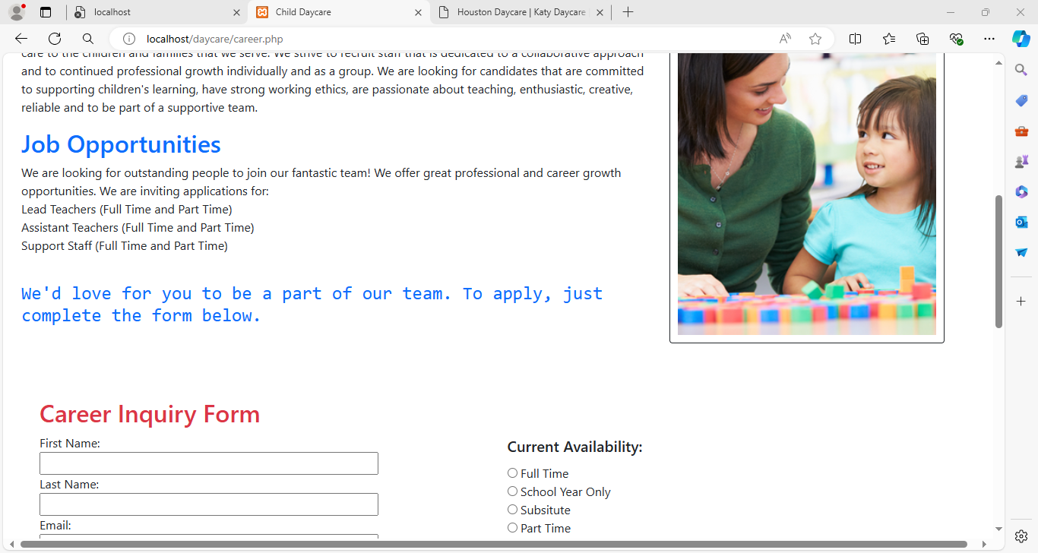

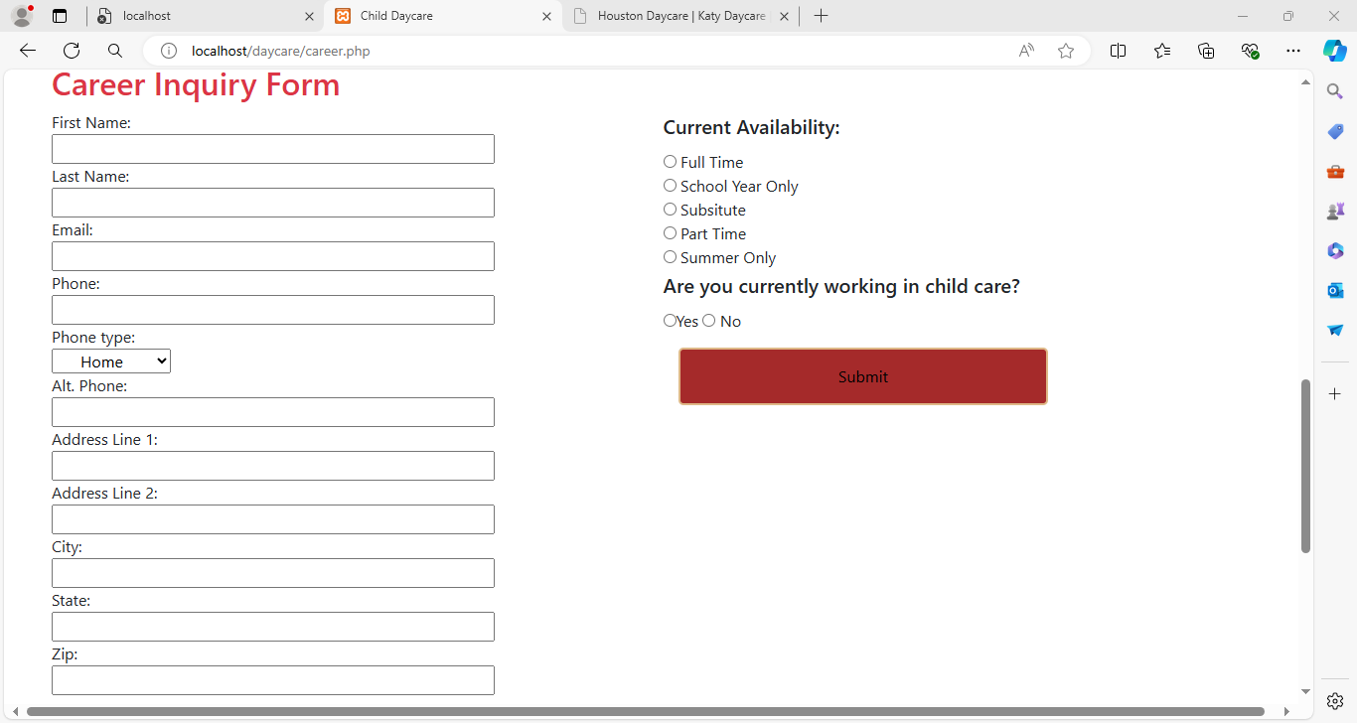

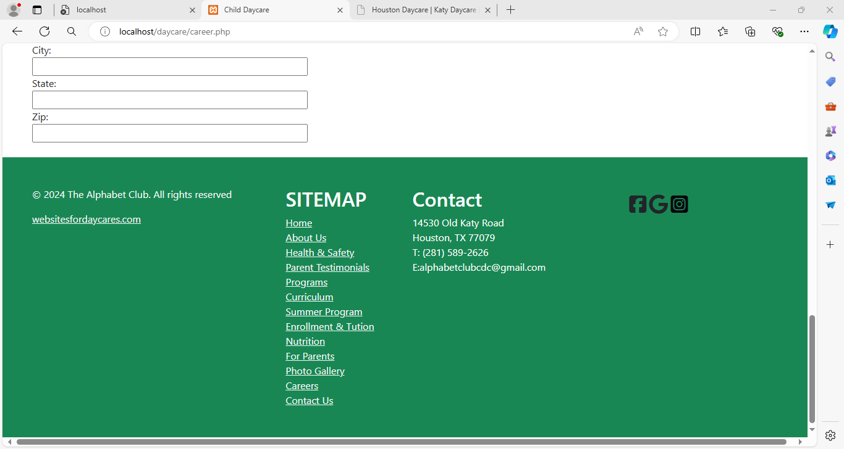

**CONTACT**

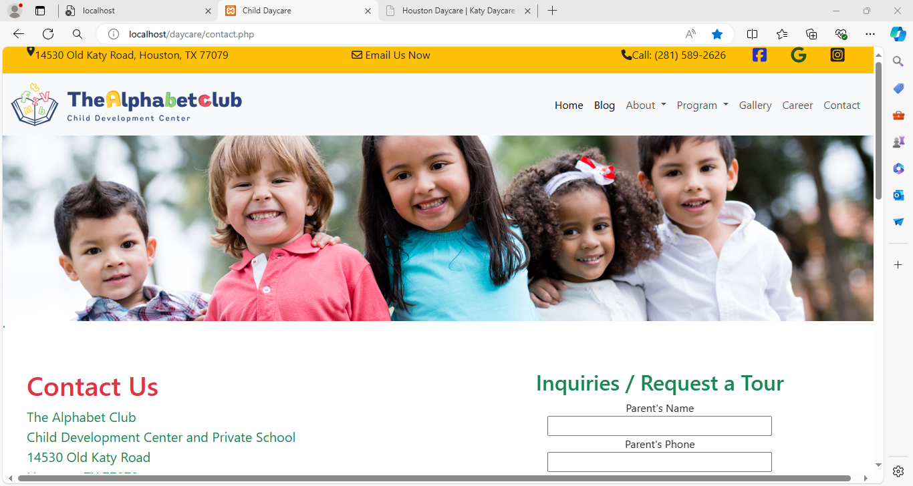

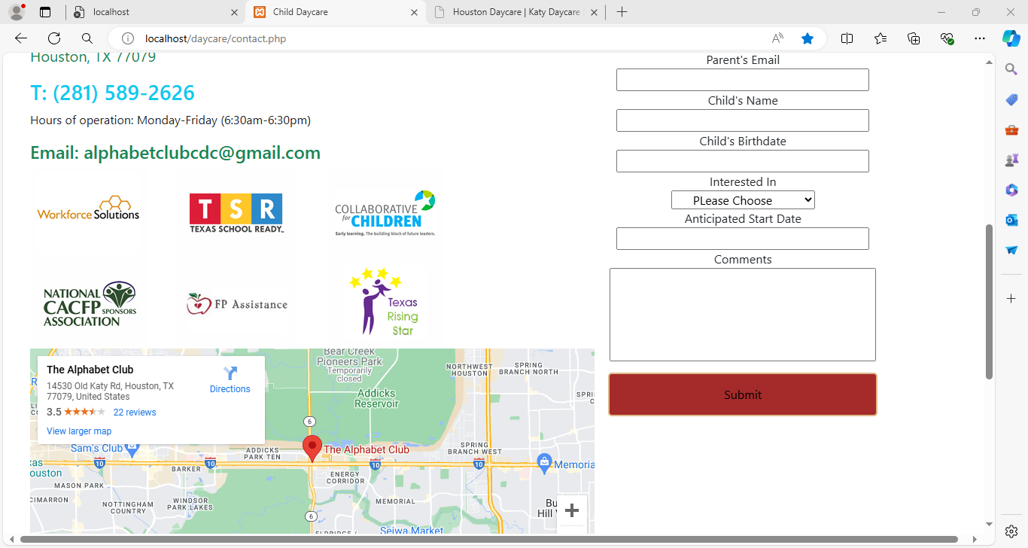

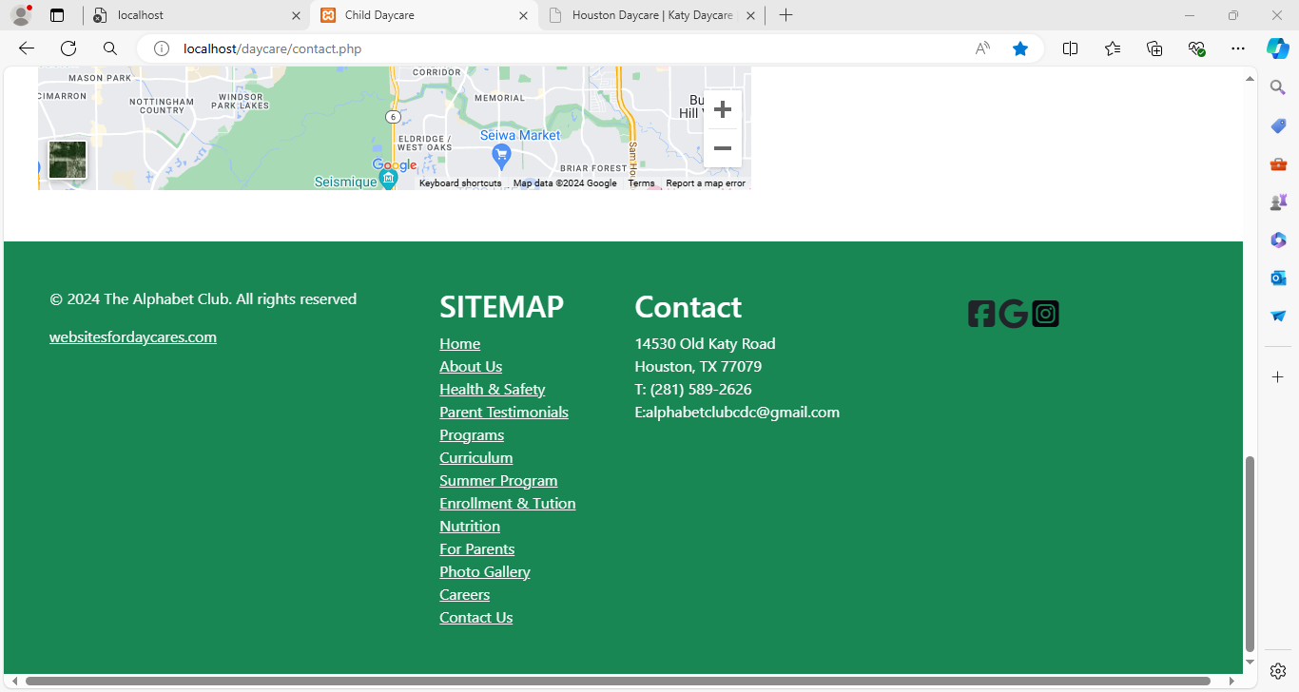

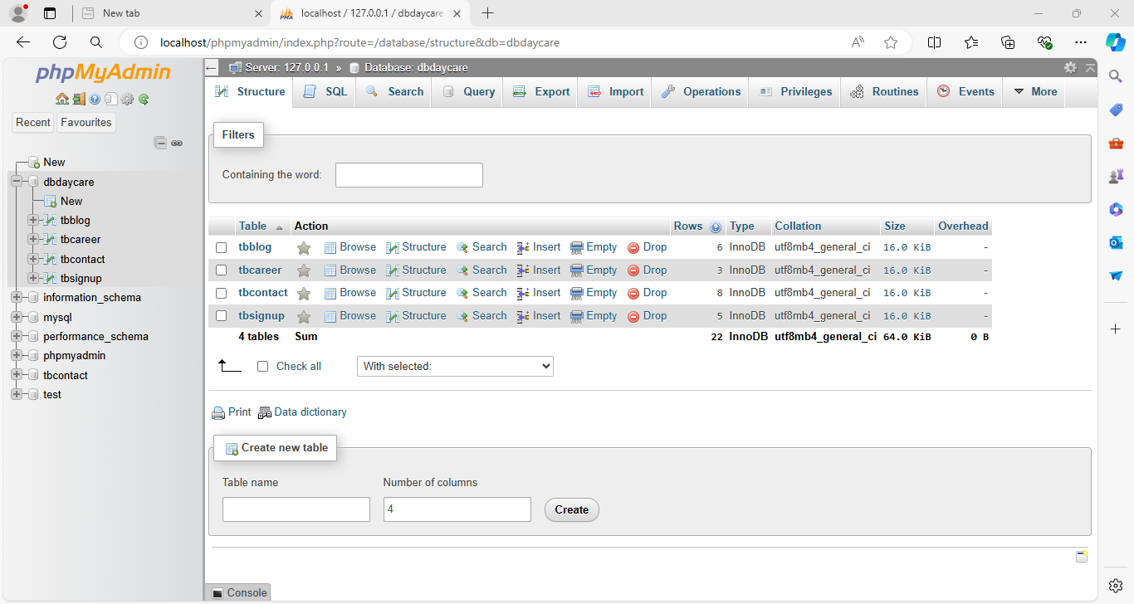 **DATABASE**

**CHAPTER-6**

**TESTING**

During testing the program to be tested is executed with the set of test cases and have the output of the program for the test cases is evaluated to determine if the program is performing as expected. Due to its approach dynamic testing can only ascertain the presence of errors in the program, the exact nature of errors is not usually decided by testing. Testing forms is the first in determining errors in the program.

Once the programs are tested individually then the system as a whole need to be tested. During testing the system is used experimentally to ensure that the software does not fail i.e. it will run according to its specification. The programs executed to check for any syntax and logical errors. The Errors are corrected and test is made to determine whether the program is doing what it is supposed to do.

This system is tested using unit testing firstly then all the modules are integrated and again the system is tested using integrated testing and it was find that system is working according to its expectation.

**Why testing is done**

Testing is the process of running a system with the intention of finding errors.

Testing enhances the integrity of a system by detecting deviations in design and errors in the system. Testing aims at detecting error-prone areas. This helps in the prevention of errors in a system.

**Testing Principles**

To discover as yet undiscovered errors.

All tests should be traceable to customer’s requirement.

Tests should be planned long before the testing actually begins.

Testing should begin “in the small” &amp; progress towards “testing in the large”.

Exhaustive Testing is not possible.

To be most effective training should be conducted by an Independent Third Party

**Testing Objectives**

Testing is a process of executing a program with the intent of finding errors.

A good test case is one that has a high probability of finding an as yet undiscovered error.

A successful test is one that uncovers an as yet undiscovered error.

**TYPES OF TESTS**

The test plan specifies the different types of tests that will be performed to ensure the product meets customer requirements and does not contain defects. Table 10-1 describes the most common test types.

Test type Ensures that Unit test each independent piece of code works correctly Integration test. All units work together without errors Regression test newly added features do not introduce errors to other features that are already working Load test (also called stress test) The product continues to work under extreme usage Platform test The product works on all of the target hardware and software platforms.

A test plan has the following steps:

* Prepare test plan
* Specify conditions for user acceptance testing
* Prepare test data for program testing
* Prepare test data for transaction path testing
* Plan user testing
* Compile/Assemble program
* Prepare job performance aids
* Prepare operational documents

Test Subject Test Method Expected Result Actual Result Remarks Complete testing of system on different browsers.

The whole project is executed using different browsers like opera, Mozilla firefox, and internet explorer. The project should give the same output on all the browsers. Because High HD picture Quality, the size of the Website Become Large &amp; on executing It takes Time to View. Browser can sometimes effect the working and performance of execution of the project. Table: Test cases for system testing

* Component testing
* Integration testing
* User testing

**UNIT TESTING**

Unit testing focuses verification effort on the smallest unit of software i.e. the module. Using the detailed design and the process specifications, testing is done to uncover errors within the boundary of the module. All modules must be successful in the unit test before the start of the integration testing begins.

**INTEGRATION TESTING**

After unit testing, we have to perform integration testing. The goal here is to see if modules can be integrated properly, the emphasis being on testing interfaces between modules. This testing activity can be considered as testing the design and hence the emphasis on testing module interactions.

**SYSTEM TESTING**

Here the entire software system is tested. The reference document for this process is the requirements document, and the goal is to see if software meets its requirements. Here entire ‘HRRP’ has been tested against requirements of project and it is checked whether all requirements of project have been satisfied or not.

**ACCEPTANCE TESTING**

Acceptance Testing is performed with realistic data of the client to demonstrate that the software is working satisfactorily. Testing here is focused on external behavior of the system; the internal logic of program is not emphasized.

**WHITE BOX TESTING**

This is a unit testing method, where a unit will be taken at a time and tested thoroughly at a statement level to find the maximum possible errors

White-box test focuses on the program control structure. Test cases are derived to ensure that all statement in the program control structure.

Test cases are derived to ensure that all statement in the program has been executed at least once during testing and that all logical conditions have been exercised. Basis path testing, a white box technique, makes use of program graphs (or graph matrices) to derive the set of linearly independent test that will ensure coverage. Condition and data flow testing further exercising degrees of complexity.

**BLACK BOX TESTING**

This testing method considers a module as a single unit and checks the unit at interface and communication with other modules rather getting into details at statement level. Here the module will be treated as a block that will take some input and generate output. Output for a given set of input combinations are forwarded to other modules.

Black-box testing techniques focus on the information domain of the software, deriving test cases by partitioning the input and output.

**TEST INFORMATION FLOW**

A strategy for software testing may also be viewed in the context of the spiral. Unit testing begins at the vortex of the spiral and, concentrates on each unit, component of the software as implemented in source code.Testing progresses moving outward along the spiral to integration testing, where the focus is on designed the construction of the software architecture.

**TEST CASES AND TEST CRITERIA**

The main aim of integration test cases is that it tests the multiple modules together. By executing these test cases the user can find out the errors in the interfaces between the Modules.

In Website Testing, there will be User Panel. In this section the user can validate a specific URL.

No. of Test Description Test Inputs Expected Results 1 Check for Login Screen Enter values in Email and Password

For Eg:

Email -_HYPERLINK &quot;mailto:abc@gmail.com&quot;_abc@gmail.com_

Password-****** Inputs should be accepted. Backend Verification Select email, password from tbl_admin The entered Email and Password should be displayed at sqlprompt or phpmyadmin. 2 Check for validation Click submit or upload option It should display complete details of the errors &amp; warnings _3 __ Check for Registration Fill the detail in given form. Inputs should be accepted. Backend verification Insert data in members The entered data should be displayed at the sql prompt.

**CHAPTER-7**

**IMPLEMENTATION**

An Implementation plan is a management tool for a specific policy measure, or package of measures, designed to assist agencies to manage and monitor implementation effectively. Implementation plans are intended to be scalable and flexible; reflecting the degree of urgency, innovation, complexity and/or sensitivity associated with the particular policy measure. Agencies are expected to exercise judgment in this area; however, the level of detail should be sufficient to enable the agency to effectively manage the implementation of a policy measure.

At a minimum, plans should reflect the standards outlined in the Guide to Preparing Implementation Plans. Implementation is the stage in the project where the theoretical design is turned into the working system and is giving confidence to the new system for the users i.e. will work efficiently and effectively. It involves careful planning, investigation of the current system and its constraints on implementation, design of method to achieve the change over, an evaluation, of change over methods. A part from planning major task of preparing the implementation is education of users. The more complex system is implemented, the more involved will be the system analysis and design effort required just for implementation. An implementation coordinating committee based on policies of individual organization has been appointed. The implementation process begins with preparing a plan for the implementation for the system. According to this plan, the activities are to be carried out, discussions may regarding the equipment has to be acquired to implement the new system.

Implementation is the final and important phase. The most critical stage is in achieving a successful new system and in giving the users confidence that the new system will work and be effective. The system can be implemented only after thorough testing is done and if it found to working according to the specification. This method also offers the greatest security since the old system can take over if the errors are found or inability to handle certain types of transaction while using the new system.

At the beginning of the development phase a preliminary implementation plan is created to schedule and manage the many different activities that must be integrated into plan. The implementation plan is updated throughout the development phase, culminating in a changeover plan for the operation phase. The major elements of implementation plan are test plan, training plan, equipment installation plan, and a conversion plan.

**1 IMPLEMENTATION AND OUTPUTS**

A crucial phase in the system development life cycle is the successful implementation of the new system design. Implementation simply means converting a new system design into operation. Implementation phase is used to translate the design phase into programming constructs. Actual implementation of the project is done or we can say that in this phase we develop all the aspect of the project. In this phase the programmer also does user documentation of the project.

**Implementation Phases: -** These are the following implementation different phases.

**Phase 1: -** During this phase, the project water quality goals and plant capacity are set. Then, with assistance from membrane manufacturers and specialty consultants, a critique of various technologies is conducted to assess feasibility and cost-effectiveness of membrane options. Many utilities can complete this phase with their own staff. It is crucial to give a “yes” or “no” to membranes in this phase. Remember, membranes may not be the best option for all types of waters and in every application.

**Phase 2: -** In this phase, advice from a specialized consultant is a must. This is when layouts and conceptual design are done to evaluate membrane options. This is also the last practical and cost-effective phase where you can go back to the feasibility study if the membrane is not found to be the best alternative. Detailed water quality investigation and sometimes pilotin is done in this phase to verify membrane applicability and type of systems to use, as well a setting design parameters for the next phase. Depending on the piloting requirements and periods, this phase could take as little as two or three months to more than a year; if seasonal, water quality changes are substantial. If a pilot study is required, a detailed test protocol should be prepared to not only evaluate various manufacturers but also as a basis for operations and maintenance (O&amp;M) cost evaluation. It is highly recommended to prepare this test protocol with guidance from the permitting agencies and make them a part of the decision process.

The conclusion of Phase 2 should determine what type of membrane to use and the membrane manufacturer. If manufacturers were invited to pilot test, you must ensure that they are being evaluated in a fair and open environment. Test protocol is the key evaluation tool. It is also recommended to get them involved early in the draft test protocol so there are no surprises.

**Phase 3: -** Before starting Phase 3, all design parameters, plant capacity, reliability and redundancy factors, stand-by provisions, temperature and water quality considerations must be established. They will then become the design basis for the specialty consultant. Phase 3 is essentially when the local engineers working with the specialty consultants to perform detail designs and preparing the bidding documents while the local engineer is focusing on the site work, building, incoming power, etc. The specialty consultant is doing detail design and layout for the process equipment and setting the bidding requirements for the membrane system.

Depending on the project schedule and local requirements, typically three major submittals are prepared: 20% to 30%, 60% to 70% and 100% design. It is critical to establish the type of procurement and short list manufacturers, and identify all key process needs during the 20% to 30% phase. Even with the same membrane technology, the system layout, process needs and power/chemical requirements are very different.

**Phase 4: -** This phase is the most complex phase in membrane system implementation. There are many different methods and ways of bidding membrane systems, each with its own advantages/disadvantages.

**Phase 5: -** The success and smoothness of Phase 5 depends on phases 3 and 4. The single most important factor becomes how detailed the bid document is and who is responsible for what material and equipment, as well as testing and guarantees.

**Phases 6 and 7: -** Typically, each entity performs its own function in phases 6 and 7, except the overall controls, for which one entity should be taking charge.

**Phase 8: -** This phase is preparing as- built, final O&amp;M manuals and each entity completing its punch lists. The specialty consultant can be of great assistance to compile all O&amp;M and shop drawings and provide a comprehensive operator training on the overall plant process, while each supplier provides training of individual components.

Post implementation:-A Post-Implementation Review (PIR) is an assessment and review of the completed working solution. It will be performed after a period of live running, sometime after the project is completed.

There are three purposes for a Post-Implementation Review:

• To ascertain the degree of success from the project, in particular, the extent to which it met its objectives, delivered planned levels of benefit, and addressed the specific requirements as originally defined.

• To examine the efficacy of all elements of the working business solution to see if further improvements can be made to optimize the benefit delivered.

• To learn lessons from this project, lessons which can be used by the team members and by the organization to improve future project work and solutions.

In some cases, the first of these objectives can be a contractual issue. Where that is the case, it may be safer to run separate reviews - one focused on contractual compliance and the other seeking to derive further benefit from a no-blame review.

**TYPES OF IMPLEMENTATION**

• Implementation of a computer system to replace a manual system.

• Implementation of a new computer system to replace an existing system.

• Implementation of a modified application to replace an existing one, using the same computer.Successful implementation may not guarantee improvement in the organization using the new system, but improper installation will prevent it. It has been observed that even the best system cannot show good result if the analysts managing the implementation do not attend to every important detail. This is an area where the systems analysts need to work with utmost care.

**2. MAINTENANCE**

Once the website is launched, it enters the maintenance phase. All systems need maintenance. Maintenance is required because there are often some residual errors remaining in the system that must be removed as they are discovered. Maintenance involves understanding the effects of the change, making the changes to both the code and the documents, testing the new parts and retesting the old parts that were not changed. Maintenance is mainly of two types:

1. Corrective Maintenance

2. Adaptive Maintenance

**1.Corrective Maintenance:**

Almost all software that is developed has residual errors or bugs in them. Many of these surfaces only after the system have been in operation, sometimes for a long time. These errors once discovered need to be removed, leading to the software to be changed. This is called Corrective Maintenance.

**2.Adaptive Maintenance:**

Even without bugs, software frequently undergoes change. The software often must be upgraded and enhanced to include more features and provide more services. This requires modification of the software. This type of maintenance is known as the Adaptive Maintenance.

**Conclusion**

This is a daycare business plan for age group of 4-15. "Some of the best years inlife are the time spent as a child and later our collegiate years..." As working adultsin a fast paced society, we sometimes forget just how precious and fleeting thoseyears are.With that in mind, imagine an alternative to traditional infant, day and after schoolcare that not only met your child care needs, but also provided an activity basedlearning environment that mirrors those used at colleges, universities andvocational centers around the nation. A college community of professional caregivers with the credentials to not only enhance your child's early social and motor skills, but to also teach them advanced studies in the arts and sciences found atinstitutions of higher learning. A collegiate-based curriculum tailored specificallyfor children, taught in a fun, nurturing care giving environment. Now imagine this at a cost less than that of the combination of conventional daycare and specific interest based children programs.We will open for business starting with an initial enrollment of 30 students. We project healthy revenues by the end of the first year, and expect to nearly triple that by the end of Year 3.